E#3 - Module 3: In-Class Exercises #3

Title
Finite State Automaton for Validating 30¢ Using US Coins (1¢, 5¢, 10¢, 25¢)

1. Formal Definition
[ M = (Q, \Sigma, \delta, q_0, F) ]
- Alphabet ((\Sigma)):
({1, 5, 10, 25})
(Penny = 1¢, Nickel = 5¢, Dime = 10¢, Quarter = 25¢)
- States (Q):
({q0, q1, q2, \dots, q{30}, q_{\text{dead}}})
  - (q_0): initial state (0¢)
  - (q_{30}): accepting state (30¢)
  - (q_{\text{dead}}): dead state for invalid inputs
- Initial State:
(q_0)
- Final State(s):
(F = {q_{30}})
- Transition Function ((\delta)):
For any (qi) and coin (c \in {1,5,10,25}): [ \delta(qi, c) = \begin{cases} q{i+c}, & \text{if } i + c \le 30 \ q{\text{dead}}, & \text{if } i + c > 30 \end{cases} ] From (q{30}), any coin → (q{\text{dead}}).
From (q{\text{dead}}), all coins loop to (q{\text{dead}}).

2. Diagram
- Start State: q0 (arrow pointing to it)
- Accepting State: q30 (double circle)
- Dead State: q_dead (dashed circle with self-loop)
- Transitions:
  - From q0:
1 → q1, 5 → q5, 10 → q10, 25 → q25
  - From q25:
5 → q30, others → q_dead
  - From q20:
10 → q30, others → q_dead
  - From q30:
any coin → q_dead
- Legend:
1 = Penny, 5 = Nickel, 10 = Dime, 25 = Quarter

3. Transition Rule Explanation
- Add coin value to current total.
- If total ≤ 30 → move to new state.
- If total > 30 or after reaching 30 → go to dead state.
- Accept only if final state is q30.

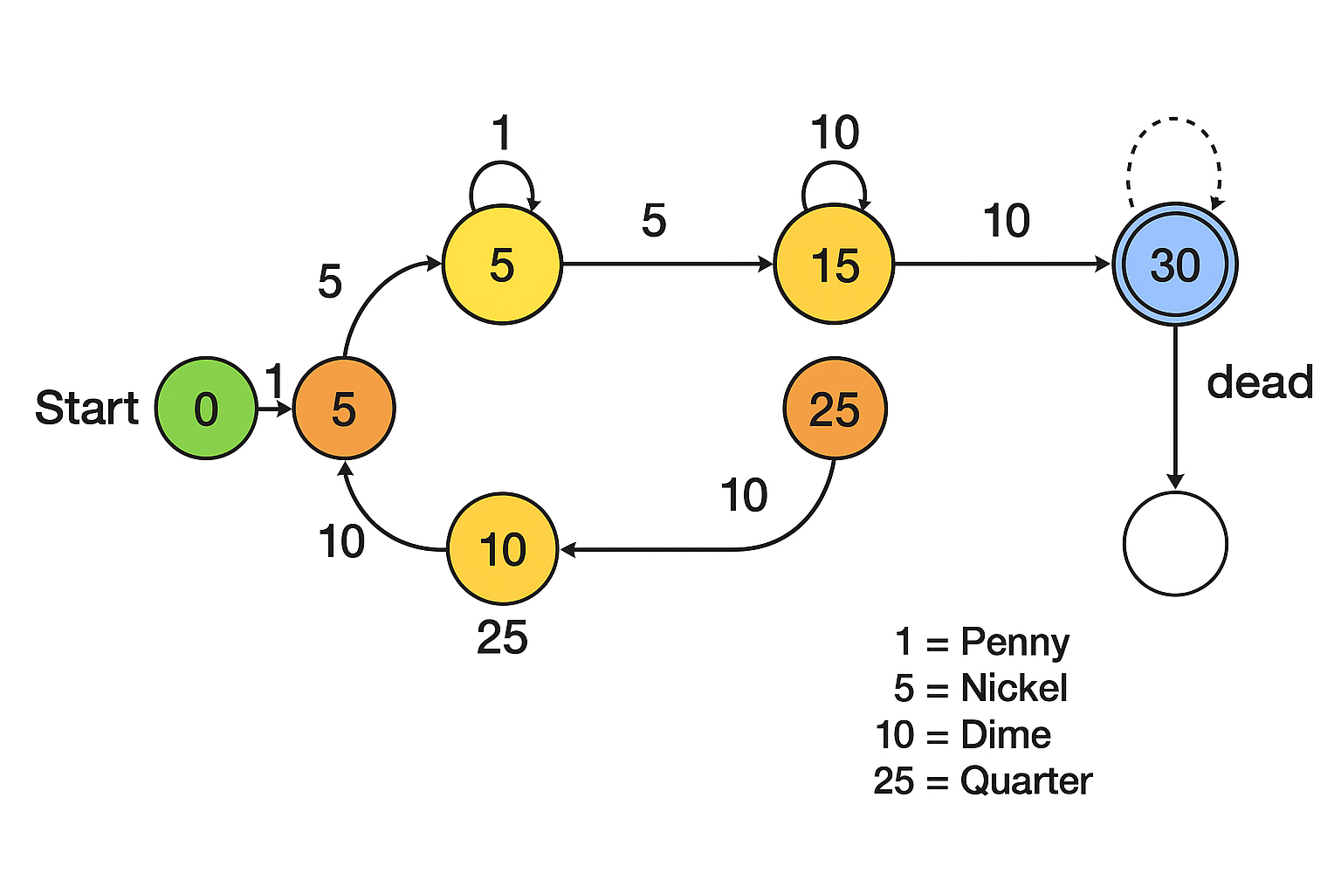
4. Examples
- Input: 10, 10, 10 → q0 → q10 → q20 → q30 (Accept)
- Input: 25, 5 → q0 → q25 → q30 (Accept)
- Input: 10, 25 → q0 → q10 → q_dead (Reject)
- Input: 30, 1 → q0 → q_dead (Reject)

5. Optional Appendix: Full Transition Table

Current | Coin | Next
q0 | 1 | q1
q0 | 5 | q5
q0 | 10 | q10
q0 | 25 | q25
q1 | 1 | q2
q1 | 5 | q6
… | … | …
q29 | 1 | q30
q30 | any | q_dead
q_dead | any | q_dead

Compliance Checklist
Alphabet: {1, 5, 10, 25}
States: q0–q30 + q_dead
Transition function: Complete and correct
Initial state: q0
Final state: q30
Dead state for invalid inputs
Diagram readable and labeled

